Filippa Gojo – Stephan Mattner // Nucleus

vocals//kaoss pad//keys – soprano sax//computer//keys

*minimal chaos music*

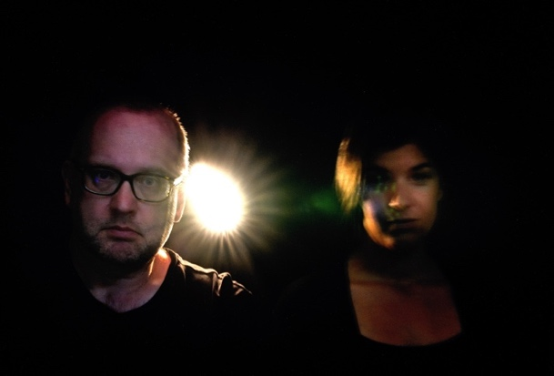

*photo: Kurt Rade*

[***Press Kit and Music Download***](https://www.dropbox.com/scl/fo/g9w4xjfxw46bhjmgyl0qs/h?rlkey=rl8cjac47sm5w3280bfd5ly7q&dl=0)

[***www.gojo-mattner.de***](https://gojo-mattner.de/)

The search for the essence, the core of things: This is a task that both singer Filippa Gojo and saxophonist Stephan Mattner set themselves early on in their respective musical developments. So it was only a matter of time that the two Cologne-based musicians continued this exploration together.

On the one hand, reduced to voice and soprano saxophone, and on the other hand expanded through targeted effects and computer sounds, the Duo Nucleus combines exactly that: reduction to the essential in connection with the abstract, the not quite tangible. The relationships between the levels are also constantly changing: sometimes the elements clearly stand out from one another, unmistakably separate in accompaniment and melody, in electronics and acoustics, sometimes they merge with each other without any audible separation.

**Filippa Gojo** – vocals, kaoss pad, keys

When her jazz singing studies took her to the University of Music and Dance in Cologne, she soon found herself in the middle of the action with German jazz greats and renowned orchestras such as the WDR Bigband, as well as her own quartet.

She gained further inspiration and experience during a semester abroad at the “Conservatorium van Amsterdam” in the winter semester of 2010/2011.

After graduating with a diploma in jazz singing from the University of Music and Dance in Cologne, Filippa also completed her master's degree in her adopted home. In 2014 she was the first singer to be awarded the City of Cologne's scholarship for jazz and improvised music, the Horst and Gretl Will Scholarship, and in 2015 she received both the band prize of the NEW GERMAN JAZZ PRIZE and the SOLIST PRIZE with her “Filippa Gojo Quartet”.

From 2016 to 2023, Filippa Gojo was a lecturer in jazz-pop singing at the Freiburg University of Music. She has been a professor at the Nuremberg University of Music since 2023.

“This music touched my soul” (Kenny Garrett)

“(…) And only very few singers can do that: entrust the unspeakable to the sound and an extremely differentiated rhythm” (Hans-Jürgen Linke, FAZ)

“Filippa Gojo’s strength is that she has retained her intuitive, original nature while still moving her voice in a trained, stylistically confident manner.” (Anja Buchmann, DLF)

**Stephan Mattner** –soprano sax, computer, keys

studied classical saxophone and instrumental pedagogy at the Detmold University of Music/Dortmund Department and jazz saxophone at the Folkwang University in Essen with Prof. Hugo Read and Matthias Nadolny.

During his studies he attended courses such as “Days for New Music Darmstadt”, was a member of the State Youth Jazz Orchestra of North Rhine-Westphalia and taught as an assistant lecturer at the Dortmund University of Music.

Concerts took him to almost all clubs and festivals in Germany as well as various European countries and Australia with a wide variety of formations and musicians.

At the Montreux International Jazz Festival he was a semi-finalist in the associated International Saxophone Competition. Radio and television recordings and broadcasts from WDR, MDR, BR, Deutschlandfunk.

In addition to various juror positions such as at the Federal Youth Jazz Competition and the North Rhine-Westphalia State Orchestra Competition, he holds a teaching position for saxophone at the University of Siegen.

He was a guest in the WDR Big Band, the Cologne Contemporary Jazz Orchestra with, among others, Nils Wogram, Gwilym Simcock, Mark Wingfield, Joachim Ulrich, Darcy James Argue, Jürgen Friedrich, Florian Ross, Frank Rheinshagen, Marko Lackner, Christoph Eidens, Niels Klein , Nicolas Simion, Sherisse Rogers, Martin Sasse, Sabine Kühlich, Frank Wunsch, Claudius Valk, Christina Fuchs Big Band, Christian Thomé, Caroline Thons Thoneline Orchestra, Big Band Convention Cologne, etc.

***Roland Spiegel: Bayerischer Rundfunk in the program Jazztime BR-Klassik June 27, 2014***

*“… is one of the outstanding soloists on the German jazz scene…”*

**Contact**

Stephan Mattner Filippa Gojo

+49 174 10 200 89 +49 163 87 116 58

[info@stephan-mattner.de](mailto:info@stephan-mattner.de) [filippa.gojo@yahoo.de](mailto:filippa.gojo@yahoo.de)

[www.gojo-mattner.de](https://gojo-mattner.de/)